SOME CURRENT AREAS OF CONCERN FOR OLDER PEOPLE:  PROMOTING POSITIVE AGEING and INCLUSION  Challenge negative stereotypes of older people and ageism.  EQUAL ACCESS TO OUR CITY AND SERVICES  Access to friendly help and advice when needed without needing internet,  Digital only information excludes many older people.  Information dissemination through community navigators.  Single phone contact to get help and advice.  Better engagement of older people in decisions  ENVIRONMENT AND OUTDOOR SPACES  Parks with the facilities to exercise and meet other people.  More seating and toilet access throughout the city.  Safer pavements to prevent falls, without obstruction or bikes  Access to the seafront and beach.  HEALTHCARE  Wellbeing centres or mobile clinics for routine treatments.  More GPs within easy reach, face to face, easier appointment booking, and more home visits. Understandable information about social care, & high quality services.  COMBATTING POVERTY and ENCOURAGING TAKE UP OF BENEFITS  Especially Pension Credit. Campaign for Universal payments campaign e.g. winter fuel.  TRANSPORT  Maintain current bus pass use outside statutory times. Maintain bus subsidy especially to remote areas. Continued and improved access to community bus services. Freedom pass to include local rail services.  More disabled car parking, & Car parking without needing internet or phones.  COMMUNITY SUPPORT AND ACTIVITY  More local companion groups.  City wide neighbourhood care scheme.  Support for community groups catering for diverse tastes and interests.  More evening events for older people.  Better communication of events suited for older people. |  |   OLDER PEOPLE'S COUNCIL(OPC) – Brighton & Hove  Contact us on brightonhoveOPC@gmail.com  Website: http://olderpeoplescouncil.org  OPC is an independent body established in 2001 with the support of Brighton & Hove City Council  The Older People's Council work to help create a city in which:  - The contribution of all older people is acknowledged and valued.  - The needs of older people are recognised and met.  - Older people are involved in the making of decisions that affect their daily  lives and the communities in which they live.  Our commitments :  1. We will listen to and represent the views of older people in Brighton &  Hove to influence change.  2. We will challenge disadvantage experienced by older people and  promote their human and civil rights.  3. We will scrutinise, and actively promote the needs of older people to  achieve good quality public services  4. We will promote dignity, and support the aspirations of older people  wherever they live.  5. We will publicise our work.  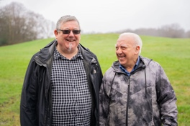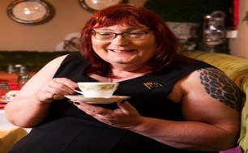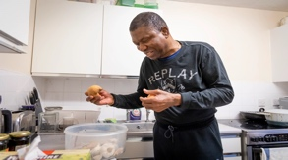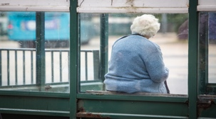  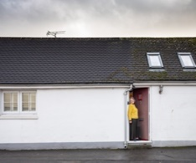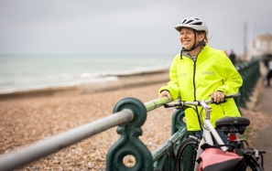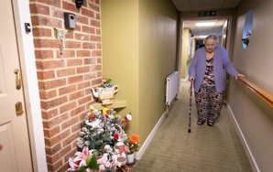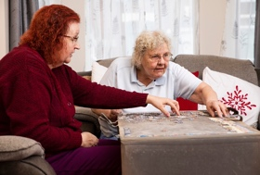  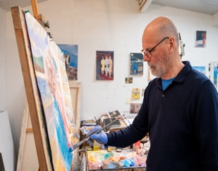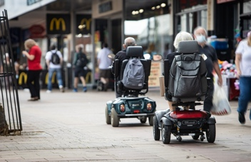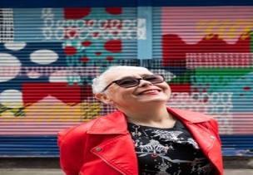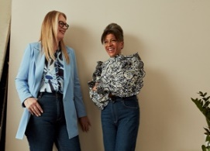

Areas of particular concern to older people that inform our work:
AREA OF WORK | Health & Social Care | Housing | Outdoors & Transport | Community & Social Inclusion | Communication &  Social Isolation
WHAT WE WANT | Good quality GP, hospital, and ambulance services. Timely treatment given with courtesy and respect. Information available on paper & digital formats. Good quality integrated care and health facilities  Face to face services & appointments.  Easy and accessible phone lines. | Sufficient, affordable, adaptable homes. Affordable repair service locally available. A good proportion of new build homes to be suitable for older residents. Sufficient suitable homes available to downsize within our existing communities. | Environment to be pleasant, clean & obstruction free. Accessible public buildings.  Access to sufficient number of clean toilets. Affordable, reliable transport.  Sufficient bus stops for those who cant walk far. Ease of parking. | Accessible venues, wide range of events for all ages and suitable for diversity of older people. Information easily understandable & Accessible. Access to services and information without needing internet or smartphones  Face to face services & appointments.  Easy and accessible phone lines. | Easily read, understandable paper-based information. Access to real people to speak to. Listening and hearing our needs and concerns.  An accessible City with seats in public areas, toilets open throughout the day & evening, easy parking and public transport.
HOW WE WORK | The Brighton and Hove Older People's Council (OPC) is an independent, non-party-political, voluntary, listening, advising and campaigning group that is free to attend and participate in. It gives a voice to people aged 50 and over who reside in the Brighton and Hove City Council area. We act as critical friends to the Council, attend relevant council and health meetings, scrutinise policies, invite policy decision makers to our meetings & take part in consultations. We are in regular contact with other older people-related organisations. We publicise issues through public meetings, community contacts and writing to decision makers. The OPC holds regular public meetings. If you would like to be added to our distribution list, do please let us know by emailing brightonhoveopc@gmail.com
SOME OF OUR SUCCESSES   | Participation on the Health Overview Scrutiny Committee (HOSC). Responses to Healthwatch surveys. | Participation on the People and Place Scrutiny Committees. Contribution to Senior housing policy; city plan consultations. | Campaigning for reduction in cuts to public toilets. Enhanced bus pass availability.  Participation in Council Scrutiny  Committees | Support of WHO Age & Dementia Friendly City status; Participation in the Older People's Wellbeing Festival, and network of organisations.  Participation in Council Scrutiny Committees | Open meetings format with invited speakers on varying areas of interest. Website & email, WhatsApp group, and paper notices of activities for member involvement.
scan me with a phone

